**Peripheral factors affecting human  
colour perception**

Lauren Elizabeth Welbourne

Submitted for the degree of PhD

University of York

Psychology

Month & Year

Abstract

Table of contents

1. Chapter 1 15

1.1 Overview 15

1.2 Unique green 16

1.2.1 MPOD and unique green 19

1.2.2 Environmental adaptation 22

1.3 A dichromatic advantage – remapping neuronal tuning 28

1.3.1 Genetics and physiological of human colour vision 29

1.3.2 Camouflage task advantage 37

1.3.3 Visual “pop-out”: Saliency 40

1.3.4 Neuronal tuning and population Receptive Fields (pRFs) 44

1.4 Tetrachromacy 48

1.4.1 Genetic and physiological aspects of tetrachromacy 49

1. Chapter 2 Unique hues – a longitudinal experiment 56

2.1 Overview 56

2.2 Unique Green 57

2.3 Unique Yellow 57

2.4 Aims & hypotheses 57

2.5 Methods 58

2.5.1 Subjects 58

2.5.2 Equipment 58

2.5.3 Design 61

2.5.4 Procedure 61

2.6 Results 65

2.6.1 Rayleigh matches 66

2.6.2 Unique Green 66

2.6.3 Unique Yellow 66

2.6.4 Spectral measurements 67

2.6.5 Lab temperature between seasons 68

2.7 Discussion 69

2.7.1 Controls and considerations 69

2.7.2 Unique yellow settings shift between seasons 69

2.7.2.1 Modelling 69

2.7.3 Unique green modelling 69

2.7.4 Modelled shift using spectral measurements 69

2.7.5 Implications for thesis 69

2.8 Conclusion 69

2.9 Summary 69

1. Chapter 3 Saliency – a preliminary investigation 70

3.1 Overview 70

3.2 Experiment 1: saliency and camouflage 70

3.2.1 Introduction 70

3.2.2 Methods 70

3.2.2.1 Subjects 70

3.2.2.2 Equipment 70

3.2.2.3 Design 70

3.2.2.4 Procedure 70

3.2.3 Results 70

3.2.3.1 Colour vision testing 70

3.2.3.2 Reaction time data 71

3.2.3.3 Accuracy data 71

3.2.4 Discussion of Experiment 1 71

3.2.4.1 No difference between groups 71

3.2.4.2 Limitations of the stimulus 71

3.3 Experiment 2 – fMRI and saliency 71

3.3.1 Introduction 71

3.3.2 Methods 71

3.3.2.1 Subjects 71

3.3.2.2 Equipment 71

3.3.2.3 fMRI protocols 71

3.3.2.4 Experiment Design 71

3.3.2.5 Procedure 71

3.3.3 Results 71

3.3.3.1 Identifying ROIs 71

3.3.3.2 Activity differences between conditions 72

3.3.4 Discussion of Experiment 2 72

3.3.4.1 V1 saliency hypothesis 72

3.3.4.2 Implications for the thesis 72

3.4 Summary of Results 72

3.5 Discussion 72

3.6 Conclusion 72

3.7 Summary 72

1. Chapter 4 Visual Processing in Dichromats 73

4.1 Overview 73

4.2 Aims and Hypotheses 73

4.3 Methods 73

4.3.1 Subjects 73

4.3.2 Equipment 73

4.3.3 Design 73

4.3.4 Procedure 73

4.4 Results 74

4.4.1 Diagnosis of colour vision deficiency 74

4.4.2 Fitting psychometric functions 74

4.4.3 Bootstrapping the data 74

4.5 Discussion 74

4.5.1 Analysing group differences 74

4.5.2 Implications of data 74

4.5.2.1 Support of reallocation hypothesis 74

4.6 Conclusion 75

4.7 Summary 75

1. Chapter 5 pRF mapping 76

5.1 Overview 76

5.2 Aims and hypothesis 76

5.3 Experiment 1: pilot chromatic pRF mapping 76

5.3.1 Introduction 76

5.3.2 Methods 76

5.3.2.1 Subjects 76

5.3.2.2 fMRI protocol 76

5.3.2.3 Experiment and stimulus design 76

5.3.2.4 Protocol 76

5.3.3 Results 77

5.3.3.1 Retinotopic maps and ROIs 77

5.3.3.2 Size of visual areas 77

5.3.3.3 pRF size versus eccentricity 77

5.3.4 Discussion of Experiment 1 77

5.3.4.1 Pink noise vs drifting checkerboards 77

5.3.4.2 Consequence of bar width 77

5.4 Experiment 2: chromatic pRF mapping in trichromats 77

5.4.1 Introduction 77

5.4.2 Methods 77

5.4.2.1 Subjects 77

5.4.2.2 fMRI protocol 77

5.4.2.3 Experiment and stimulus design 78

5.4.2.4 Protocol 78

5.4.3 Results 78

5.4.3.1 Retinotopic maps and ROIs 78

5.4.3.2 Size of visual areas 78

5.4.3.3 pRF size versus eccentricity 78

5.4.4 Discussion of Experiment 2 78

5.4.4.1 Effect of narrower bars on pRF sizes 78

5.4.4.2 Differences between chromatic pRF data/why doesn’t it work 78

5.5 Experiment 3: chromatic pRF mapping in dichromats 78

5.5.1 Introduction 78

5.5.2 Methods 79

5.5.2.1 Subjects 79

5.5.2.2 fMRI protocol 79

5.5.2.3 Experiment and stimulus design 79

5.5.2.4 Protocol 79

5.5.3 Results 79

5.5.3.1 Retinotopic maps and ROIs 79

5.5.3.2 Size of visual areas 79

5.5.3.3 pRF size versus eccentricity 80

5.5.4 Discussion of Experiment 3 80

5.5.4.1 Difference between achromatic and chromatic conditions 80

5.6 Discussion of Results 80

5.7 Conclusions 80

5.8 Summary 80

1. Chapter 6 Development of cone isolating stimuli 81

6.1 Overview 81

6.2 Method used 81

6.3 Experiment 1: Developing the LED equipment 82

6.3.1 Introduction 82

6.3.2 Method 82

6.3.2.1 Subjects 82

6.3.2.2 Equipment 82

6.3.2.3 Design/fMRI 82

6.3.2.4 Procedure 82

6.3.3 Results 84

6.3.3.1 Psychophysics? 84

6.3.3.2 fMRI data 84

6.3.4 Conclusion 85

6.4 Experiment 2: Modification of equipment 85

6.4.1 Introduction 85

6.4.2 Method 86

6.4.2.1 Subjects 86

6.4.2.2 Equipment 86

6.4.2.3 Design 86

6.4.2.4 Procedure 86

6.4.3 Results 87

6.4.3.1 Between groups (all at 2Hz) 87

6.4.3.2 One subject at different frequencies 87

6.4.4 Conclusion 87

6.5 Experiment 3: Accounting for a 4th cone 87

6.5.1 Introduction 87

6.5.2 Methods 87

6.5.2.1 Subjects 87

6.5.2.2 Equipment 88

6.5.2.3 Design 88

6.5.2.4 Procedure 88

6.5.3 Results 88

6.5.4 Conclusion 88

1. Chapter 7 Tetrachromat testing 89

7.1 Overview 89

7.2 Experiment 4 – Psychophysics 89

7.2.1 Introduction 89

7.2.2 Methods 89

7.2.2.1 Subjects 89

7.2.2.2 Equipment 89

7.2.2.3 Design 89

7.2.2.4 Procedure 89

7.2.3 Results 89

7.2.4 Conclusion 89

7.3 Experiment 5 - fMRI 90

7.3.1 Introduction 90

7.3.2 Methods 90

7.3.2.1 Subjects 90

7.3.2.2 Equipment 90

7.3.2.3 Design 90

7.3.2.4 fMRI Protocols 90

7.3.2.5 Procedure 90

7.3.3 Results 90

7.3.4 Conclusion 90

List of Figures

List of Tables

Acknowledgements

Declaration

# 

## Overview

Rethink what this chapter should contain – at the moment it’s covering stuff that needs to be discussed in context, e.g. the unique hue lit directly relating to the experiment. Instead, maybe make it more general, i.e. what are unique hues, what’s already known about them, then what do I want to know. Next a section on photoreceptors, details about colour vision processing from this level, leading into colour vision deficiencies and the questions that arise from them (i.e. neural consequences of dichromacy). Finally, lead into the tetrachromacy work by discussing what the previous literature has looked at – the carriers of anomalous trichromacy tended to show deficits similar to the anomTris – and how I intend to be able to test them and why that would be interesting/what my hypotheses are.

The human experience of colour is not only mediated by cortical processes, but by factors peripheral to the cortex which affect both the wavelengths of light that reach the retina as well as the capacity to transmit information about these wavelengths to the cortex. There are a number of physiological components of the eye that influence the colours we perceive, such as: corneal filters, yellowing of the lens, macular pigment density, and the types and ratio of photoreceptors present in the retina. In addition to these physiological components, the environment we are surrounded by can also have an affect on our perception by means of adaptation (for example, Laeng et al., 2007; Yamauchi et al., 2002). This thesis will focus on two of these factors, the environment and photoreceptors, in the following specific contexts: the affect of environmental adaptation on the percept of unique hues, identifying advantages of human dichromacy, and investigating the retinal and cortical differences between functional and structural tetrachromats. In order to answer the key question of this thesis – “how is our cortical perception of colour affected by peripheral factors?” – I will use a combination of psychophysical techniques, functional magnetic resonance imaging (fMRI), and visual field mapping techniques (to determine retinotopic areas as well as population receptive field maps). The aim of this chapter is to outline key background literature and to provide the objectives and primary hypotheses for each of the peripheral factors that will be examined throughout my thesis.

## Unique green

From the late 19th century, the observation that particular hues could be reliably set to fit the criteria of a “unique hue” was being investigated. A hue that does not appear to contain a mixture of any other colour, for instance a green that does not appear yellowish nor bluish, can be considered unique; the four recognised unique hues are red, green, yellow and blue. The initial fascination with unique hues focused on their spectral location (Hering, 1890; Maerz & Paul, 1930; Verbeek & Bazen, 1935; von Bezold, 1876; Westphal, 1910 - reviewed by Dimmick & Hubbard, 1939) however it became apparent that unique green is notable amongst the four unique hues for having a larger variance in wavelength settings within the population than any of the other unique hues (Kuehni, 2004; Nerger, Volbrecht, & Ayde, 1995; Schefrin & Werner, 1990; Webster et al., 2002; Webster, Miyahara, Malkoc, & Raker, 2000). This led a number of researchers to suggest that there may in fact be a bimodal distribution of unique green wavelength settings (see **Error! Reference source not found.**), caused by two classes of trichromatic observers (Cobb, 1975; Richards, 1967; Rubin, 1961; Waaler, 1967), however, further studies did not support this suggestion (Hurvich, Jameson, & Cohen, 1968; Jordan & Mollon, 1995; Metz & Balliet, 1973; Schefrin & Werner, 1990), including a recent paper that investigated the distribution of unique green wavelengths by re-analysing past research using a more modern and robust test of unimodality, Hartigan’s dip test (Hartigan & Hartigan, 1985), which was not available at the time many of these past studies were published (Welbourne, Thompson, Wade, & Morland, 2013).



Figure 1 Histogram of unique green wavelength settings from Rubin (1961), demonstrating a bimodal distribution. Recreated from Rubin (1961).

Within this study, new data was also collected from 58 trichromatic participants to measure their unique green wavelength settings. The analysis of the revisited papers and the new data strongly supported a unimodal distribution of unique green values existing within the population (see Figure 2); only one of the existing papers that supported a bimodal distribution actually demonstrated a high likelihood of bimodality on the dip test.

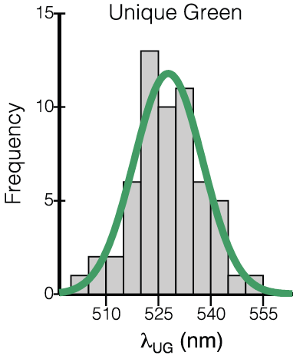

Figure 2 Histogram of unique green wavelengths, showing a unimodal distribution. Taken from Welbourne et al (2013).

Two main factors that may affect unique green wavelength variance will be considered: Macular pigment optical density (MPOD) and environmental adaptation. The following sections will detail the surrounding literature and describe methodology for investigating these factors.

### MPOD and unique green

To further investigate large individual differences in unique green wavelength settings, it is important to consider the physiological components of the retina that may affect the wavelengths of light reaching the photoreceptors. Macular pigment (MP), which contains two yellowish carotenoids (lutein and zeaxanthin), is located within the central 7mm2 of the retina and has a distribution that is at its peak in the fovea and slowly declines with eccentricity (Davies & Morland, 2004). MP acts as a filter absorbing short wavelength light between 400 and 500nm before it reaches the photoreceptors (Broekmans et al., 2002; Davies & Morland, 2004; Trieschmann et al., 2008). Higher densities of MP absorb a larger amount of short wavelength light than lower densities, and the density of this pigment can vary over 1 log unit between individuals (Dain, Cassimaty, & Psarakis, 2004; Davies & Morland, 2004; Trieschmann et al., 2008; Werner, Donnelly, & Kliegl, 1987). This variance in density results in a difference in the amount of short wavelength light that reaches the photoreceptors between individuals. Welbourne et al (2013) investigated the impact MP has on unique green by comparing estimates of macular pigment optical density (MPOD) with wavelength settings of unique green. A Wright Colorimeter (Wright, 1928, 1939) (see Figure 3) was used for both measurements (see Chapter… section… for detailed descriptions of the procedure for these measurements). 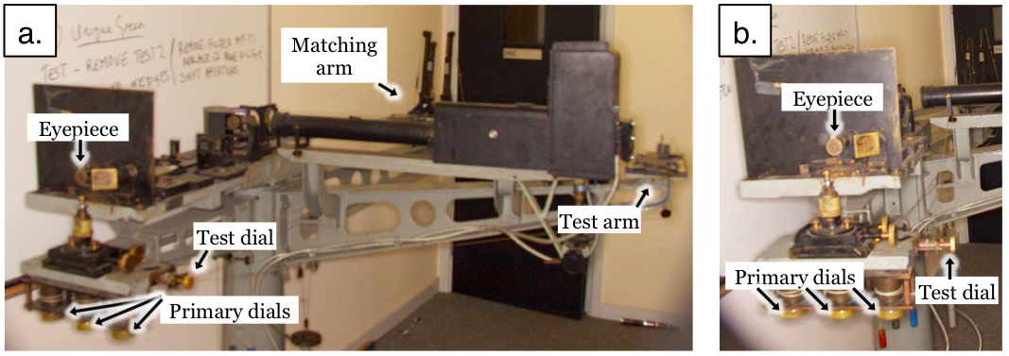

Figure 3 **The Wright colorimeter shown from different angles, (a) with the matching and test arms in view, and (b) a subject’s view of the eyepiece and dials used to alter the stimuli**

The relationship between MPOD and unique green was found to be significant, with higher MPOD associated with longer wavelength settings. It was suggested that the yellowish MP (which absorbs a greater amount of short wavelength light in individuals with a high density of MP) affects the monochromatic wavelength of light selected to mimic the broadband experience of unique green – a longer wavelength is selected if the broadband experience of unique green contains less short wavelength light due to greater MP absorption. In order to find further evidence in support of this work, experiments presented in this thesis will collect on- and off-axis measurements of MPOD, unique green and unique yellow. As MP is at its highest density in the fovea, and decreases with eccentricity, it should be possible to see a change in on-axis and off-axis measurements in unique green settings as an effect of the change in MPOD.

In this experiment, unique yellow measurements (both on- and off-axis) will also be taken. These will primarily act as a comparison measure to unique green; there should be no relationship between MPOD and unique yellow settings, or a significant difference between on- and off-axis measurements of unique yellow in relation to MPOD. In addition, measurements of unique yellow will allow a comparison to the variance in unique green settings within a population – it is expected that the variance in unique green settings will be larger than unique yellow settings.

In summary, the key hypotheses are as follows: 1) off-axis measurements of unique green should be equal to or shorter in wavelength than on-axis measurements, 2) a significant relationship between the difference in unique green on- and off-axis wavelength settings and MPOD is expected (larger differences in on- and off-axis unique green should be associated with higher MPOD), 3) a large variance in unique green wavelengths settings is anticipated (consistent with previous studies), and it is also expected that the distribution of these wavelengths will be unimodal, as tested by Hartigan’s dip test (Hartigan & Hartigan, 1985), 4) finally, based on previous literature, it is expected that the variance in unique green settings will be greater than the variance in unique yellow settings.

### Environmental adaptation

In addition to physiological factors, a number of studies have looked into the affect of environment on both colour discrimination and unique hues, though the most notable unique hue research focuses specifically on unique yellow. Yamauchi et al (2002) investigated whether L/M cone ratios or visual experience had an affect on unique yellow wavelength settings i.e. is colour vision determined by an experience-based mechanism that would alter the percept of unique yellow after long-term chromatic adaptation, or it colour vision hard wired so that regardless of environmental changes the perception of monochromatic light would not be altered (e.g. after a period of adaptation)? Unique yellow is considered to be the equilibrium point of the red-green colour opponent channel, and it has been predicted that this is strongly determined by the L/M cone ratio. Therefore it may be expected that there would be a difference in unique yellow wavelength settings between individuals with large and small L/M cone ratios. Yamauchi et al investigated this by using two subjects with large differences in their L/M cone ratios (1.15 and 3.79). They first carried out a method of adjustment task to narrow down the likely wavelength range for unique yellow in each participant. A forced choice procedure (“reddish” or “greenish”) was then implemented using five wavelength values (each 1nm apart, and presented for 0.5s) – the unique yellow point was deemed as the 50% point of a psychometric function fit to the data after 20 trials of each wavelength had been performed. It was predicted that there would be a difference of approximately 84nm in unique yellow settings if L/M cone ratios were the sole determinant of this percept, however, the results found only a 2.1 nm difference between the subjects, indicating that L/M cone ratios alone do not determine the percept of unique yellow (see Figure 4).

To investigate the affect of visual experience, a further 3 participants were used in an adaptation experiment (Yamauchi et al., 2002). There were two periods of adaptation, one to red and one to green tinted contact lenses (each over a period between 10 days and approximately 3 weeks). Unique yellow measurements were first obtained for several days prior to the initial adaptation period (on a Maxwellian-view apparatus using an adjustment method) in order to collect baseline measurements of unique yellow. Subjects were then exposed to altered chromatic environments using the tinted contact lenses for periods of 8 to 12 hours through the day; the rest of the day and night (between 12 and 16 hours) was spent in a normal visual environment. Unique yellow measurements were then taken at the start of each day, before being exposed to the altered chromatic environment. Figure 5 demonstrates the change in unique yellow wavelengths settings during and following adaptation to red-tinted contact lenses (filled circles) and green tinted contact lenses (filled squares). Over the period of adaptation to red lenses, the wavelength settings gradually shift to longer wavelengths up to a maximum shift (at the end of adaptation) of approximately 4nm from baseline, with a gradual decrease back towards the baseline after several weeks without any periods of altered chromatic environment. Similarly, the wavelength settings shift to shorter wavelengths after adaptation to green- tinted lenses, followed by a gradual return to baseline after the adaptation period. The authors conclude that the long-lasting (but reversible) effect of visual environment on unique yellow wavelength settings suggest that colour vision is mediated by a plastic normalisation process – in this case, that the equilibrium point of the red-green opponent channel is dependent on the average chromaticity of the environment. It was also apparent that it takes several weeks to both adjust to the altered environment, as well as return back to the baseline following a period of adaptation.

Figure 4 Unique yellow (UY) wavelength settings for two subjects with different L/M cone ratios. Yellow circles indicate actual UY settings, and blue triangles show the predicted UY settings for each of the L/M ratios (if it was assumed that L/M ratios were the sole determinant of UY). Data reproduced from Yamauchi et al (2002).

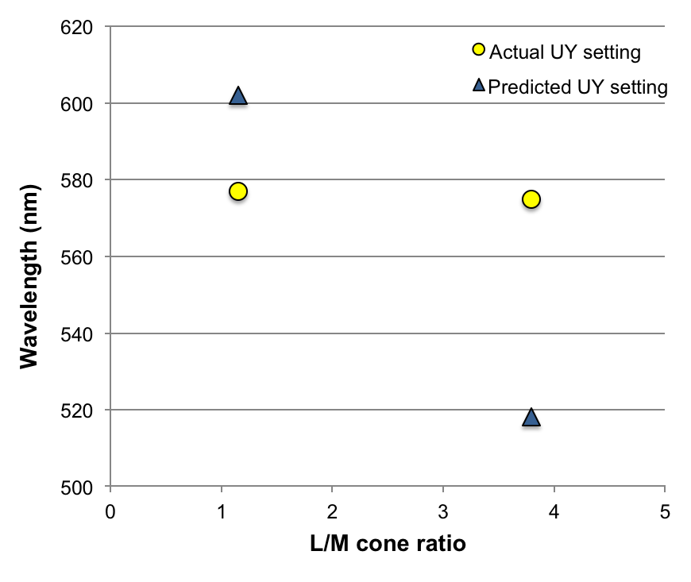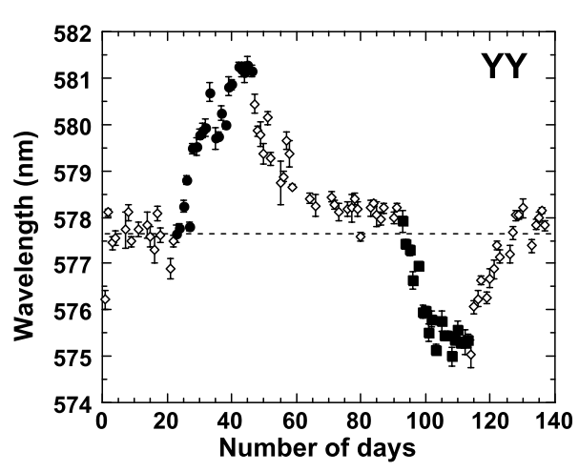

Figure 5 **Unique yellow wavelengths for one participant, over the days of the experiment. Filled circles and squares indicate the adaptation periods to red and green respectively. Open symbols show measurements taken during periods without exposure to an altered chromatic environment (taken from Yamauchi et al., 2002)**

The effect of environmental adaptation has also been investigated with regard to colour discrimination and Rayleigh matches. In Northern parts of Norway (above the Arctic Circle at a latitude of 66**°**32’ North) inhabitants are exposed to extremes in their lighting environment; during winter there are several months in which artificial lighting needs to be relied on due to the lack of direct sunlight, compared to the summer months where they are exposed to periods of constant sunlight. This means that the energy and range of wavelength spectrum varies considerably for those living above the Arctic Circle compared to those below (Laeng et al., 2007). Laeng et al (2007) investigated colour discrimination abilities using the FM100 Hue test, and found that those born above the Arctic Circle had a higher sensitivity for colours in the purple range and lower sensitivity to yellow-green, green, and green-blue, compared to those born below the Arctic Circle. Furthermore, there was a difference in overall colour sensitivity depending on the season of birth in those born above the Arctic Circle – individuals born in autumn had lower overall colour sensitivity than those born in summer. In addition to long-term affects of the environment, Jordan and Mollon (1997) have shown that colour discrimination ability is altered for approximately 5 hours following just one hour of adaptation to natural summer sunlight. Rayleigh matches were measured before and after adaptation on a Nagel anomaloscope (matching a mixture of 546nm and 671nm to monochromatic 589nm) as well as using a computer-controlled colorimeter (matching a mixture of 550nm and 690nm to monochromatic 590nm); it was found that following adaptation more red was required in the red-green mixtures in order to match the monochromatic light (see Figure 6 for Nagel anomaloscope data). The length of time this shift lasts for far exceeds any expected adaptation to light, such as after cone bleaching, where observers are expected to take only 7 minutes to fully recover (Rushton, Fulton, & Baker, 1969 - as cited in Jordan and Mollon, 1997).

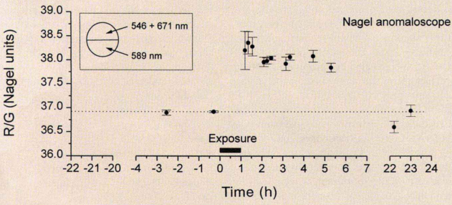

Figure 6 **Average R/G matches made on a Nagel anomaloscope over time, and following an hour of exposure to natural sunlight (as shown on graph). Taken from Jordan and Mollon (1997)**

During the mid-20th century, Richter (1948, 1951 - as cited in Jordan and Mollon, 1993) found seasonal variations in colour vision, as measured by Rayleigh matches, with subjects requiring more red in a red-green mixture to match a monochromatic yellow light during the summer months. Whilst Jordan and Mollon (1993) were able to replicate this finding, they determined that the observed changes found over the period of a year were likely due to ambient temperature fluctuations. They supported this conclusion by stabilising room temperature (to within 1°C) to keep the temperature conditions constant for the observers, and locally heating or cooling only the temperature of the prism housing of two Nagel anomaloscopes. It was found that Rayleigh matches shifted to require more red in the red-green mixture when the temperature of the prism housings were increased, and it was therefore concluded that the variations found by Richter may have been an artefact of variants in ambient temperature impacting on the anomaloscope, rather than due to changes in the observer. However, these studies do raise interesting questions regarding the potential impact of adaptation to different seasonal environments on unique green wavelength settings, regardless of the suspected lack of impact on Rayleigh matches, which has been found not to correlate with unique green measurements (Jordan & Mollon, 1995; Welbourne et al., 2013).

To date, there have been no studies investigating whether the variance in unique green wavelengths could be an affect of seasonal variance in the spectral environment. As differences in MPOD do not explain all the variance in unique green wavelength settings, one of the aims in this thesis is to tackle the question of whether differences in seasonal environments impact on the percept of unique green, specifically: does adaptation to seasonal environments – with vastly different levels of natural green surroundings (i.e. between winter and spring/summer months) – result in a shift in unique green wavelength settings, and in addition, does the overall variance in wavelengths between subjects increase or decrease between these seasons. To investigate this, a method of adjustment task will be implemented with a Wright Colorimeter to record unique green and unique yellow wavelength settings during 2 different seasons of the year (winter and spring/summer). For similar reasons to those stated previously, unique yellow will be measured in order to compare any wavelength settings differences between the seasonal measurements, to help determine whether any changes in unique green are due to an overall shift in colour perception. Rayleigh matches will also be taken for each subject, and the average room temperature between the seasonal sessions recorded to account for any affect of temperature on measurements. In addition, outdoor spectral measurements will be taken using a fibre-optic photospectrometer (“Jaz”, Ocean Optics, Dumolin, FL) in order to compare the average spectra of outdoor environments (in York, UK) during these different seasons. It might be expected that if there is an overall shift in average spectra between the seasons, e.g. a shift to longer wavelengths during summer, that individuals may need to adapt to these fluctuations in spectral environment much like the subjects in Yamauchi et al’s (2002) adaptation study. This may result in altered wavelength settings of monochromatic unique green as the subject aims to recreate the percept of green from different broadband spectral exemplars available during each season (Jordan & Mollon, 1995; Welbourne et al., 2013).

## A dichromatic advantage – remapping neuronal tuning

The types of photoreceptor present in the retina are arguably the most important peripheral factor affecting the cortical perception of colour. Our ability to interpret broadband wavelengths of light as colour starts with the stimulation of our photoreceptors. Yet whilst humans are predominantly trichromatic (have 3 types of cone photoreceptor), approximately 8% of the male population has some form colour vision deficiency due to differences in the number or normality of cone photoreceptor types.

One of the central questions of this thesis centres on why there may be such a high prevalence of colour vision deficiencies within the human population, and how differences in the number of photoreceptor types may impact on early visual processing in human primary visual cortex. These questions will be addressed in several ways: 1) by looking at the advantages of dichromacy, starting with the concept of camouflage breaking, 2) investigating saliency and its representation in the visual system, as a model for basic camouflage detection, 3) identifying population receptive fields in dichromats to investigate whether any remapping of neuronal tuning occurs, and if any remapping can be associated with behavioural advantages.

The following sections will describe genetic and physiological aspects of human colour vision, followed by an outline of the relevant literature for dichromatic advantage in camouflage tasks, present literature on saliency detection, and the methods previously used on trichromats to understand neuronal tuning that will be adopted to further our understanding of visual processing in dichromats.

### Genetics and physiological of human colour vision

The human eye contains rod and cone photoreceptors; the rods are utilised in dim light conditions and are highly sensitive to light, whereas the cones are less sensitive to light but enable us to have colour vision (Purves et al., 2001). The density of cones is at its peak in the central fovea, and then rapidly decreases with eccentricity to approximately zero at 15°. Conversely, rod photoreceptors are completely absent in the central fovea and gradually increase in density to their maximum at approximately 20° (see Figure 7).

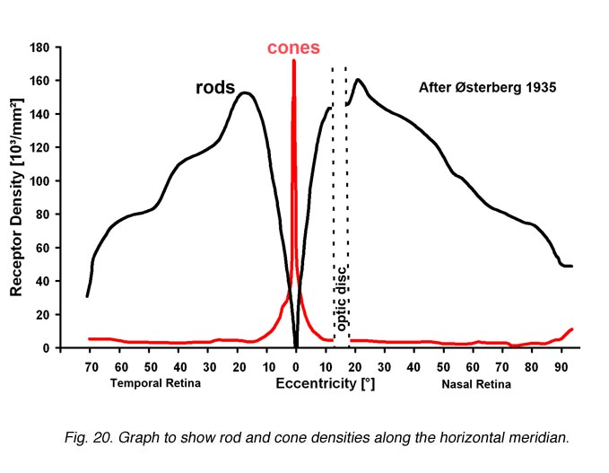Figure 7 **Distribution of rods and cones across the retina (reproduced from Osterberg, 1935).**

Possessing three different types of cone photoreceptor – trichromacy – results in 3-dimensional colour vision and is the most common type of colour vision in the human population. The three types of cone are commonly referred to by their optimal wavelength sensitivity: long (L-cones), middle (M-cones) and short (S-cones) wavelength – see Figure 8. Whilst various measurements of the L- M- and S-cones have been recorded in recent decades, with slight variation in the tails of the sensitivity distribution of the cones, they typically show the same peaks in cone sensitivities (approximately 565nm, 545nm and 440nm, for L M and S cones respectively – see Figure 9 for comparison of two such measurements).

In the retina of a trichromat the L and M cones make up the majority of all cones, with S cones contributing as few as 4% of the total number (Roorda & Williams, 1999), and whilst L and M cones are highly clustered in the central fovea, S cones are sparsely spread across the fovea. This distribution of cones across the retina is referred to as a cone mosaic, and can be imaged using an ophthalmoscope after selectively bleaching the cones with 470nm and 650nm light (Hofer, Carroll, Neitz, Neitz, & Williams, 2005) – Figure 10 shows an example of how the cones are distributed in a single trichromatic observer using a false coloured image.

Figure 8 **Psychophysical cone fundamentals for L- M- and S-cones. Recreated from Appendix A of DeMarco, Pokorny and Smith (1992).**

Figure 9 **Cone fundamentals for L (red lines) M (green lines) and S (blue lines) cones. Data shown from Demarco, Pokorny and Smith (1992) (solid lines) and Stockman and Sharpe (2000) (dashed lines).**

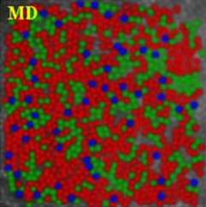Figure 10 **False colour image showing the distribution of L (red), M (green) and S (blue) cones in a single subject (taken from Hofer et al, 2005)**

The ratio of L to M cones varies considerably between individuals, with values taken from Carroll, Neitz and Neitz (2002) ranging between L:M ratios of 0.4 and 13 (though the authors note that the majority of subjects fall within a range of 1 to 4, see Figure 11).

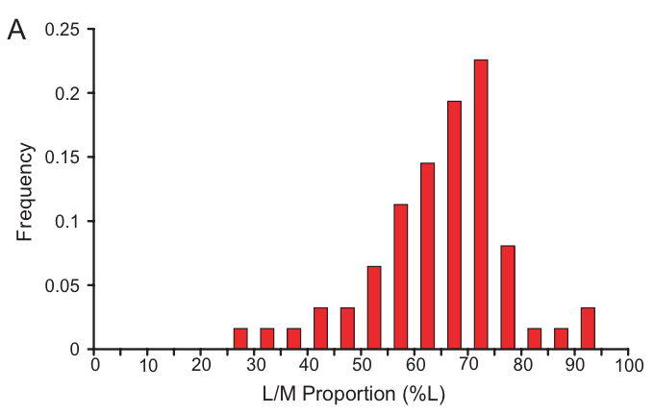

Figure 11 ERG-derived L:M cone ratios of 62 trichromatic males, presented as % L cones. Taken from Carroll, Neitz and Neitz (2002)

A number of studies have investigated the effect of these ratio differences on colour perception, such as in the aforementioned study by Yamauchi et al (2002) which found no effect of L:M cone ratios on wavelengths settings of unique yellow. Similarly, Carroll, Neitz and Neitz (2002) failed to find a significant relationship between L:M cone ratios and Rayleigh matches. However, whilst the *ratio* of L:M cones does not have any apparent affect on colour discrimination, differences in peak sensitivity of cones is known to affect the perception of colour. The most notable of these perceptual differences in colour are caused by anomalous or absent cone types – colour vision deficiencies. ‘Red-green colour blindness’ is the most common type of colour vision deficiency, and will be the only form of colour vision deficiency described within this thesis. Red-green colour blindness affects approximately 8% of males (Gegenfurtner & Sharpe, 2001; Morgan, Adam, & Mollon, 1992), and 0.42% of females (Gegenfurtner & Sharpe, 2001), and is caused by deficiencies in the sex-linked genes of the L and M cones. These deficiencies can be split into anomalous trichromacy and dichromacy, and further split into protan and deutan forms, which refers to the particular cone type that is affected (L and M cones, respectively).

Anomalous trichromats have three types of cone, like trichromats, however one of those cones (typically L or M) is abnormal – the peak sensitivity of the anomalous cone is shifted in comparison to it’s non-anomalous counterpart. This results in the wavelength sensitivity spacing of the L and M cones being much smaller, such that these individuals have a reduced ability to distinguish between colours in this region of the spectrum. Figure 12 demonstrates the cone sensitivities in protanomalous (Figure 12a) and deutranomalous (Figure 12b) individuals – L prime (L’) refers to the anomalous L cone, and M prime (M’) to the anomalous M cone. Anomalous trichromacy contributes to the largest percentage of colour vision deficiencies, affecting approximately 6% of males and 0.39% of females (Gegenfurtner & Sharpe, 2001). The degree of deficiency varies between individuals, and depends on the peak sensitivity of the anomalous cone, i.e. whether the anomalous cone has a peak sensitivity that is very close to the healthy L or M cone (Jordan, Deeb, Bosten, & Mollon, 2010; Regan, Reffin, & Mollon, 1994; Shevell, He, Kainz, Neitz, & Neitz, 1998).

Figure 12 Cone fundamentals shown for (a) protanomalous observer and (b) deutranomalous observer. Recreated from DeMarco, Pokorny and Smith (1992)



a.



b.

In comparison to anomalous trichromacy, dichromacy tends to produce similar levels of deficiency in all individuals with this condition. Dichromats have one totally absent cone type, which results in a more severe inability to distinguish between particular colours. Due to the sex-linked component of genes for L and M cones, the most common types of dichromacy are deutranopia (lack of M cones) and protanopia (lack of L cones) – see Figure 13. The prevalence is lower than for anomalous trichromacy, with approximately 2% of males being affected (Gegenfurtner & Sharpe, 2001; Morgan et al., 1992), but this is nevertheless considered a substantial percentage of the population.



b.

a.

Figure 13 Cone types (and their sensitivities) in observers with (a) deutranopia and (b) protanopia. Recreated using cone fundamentals from DeMarco, Pokorny and Smith (1992)

The cone mosaic of dichromats is consistent with a replacement model to explain the effect of having an absent cone type: the total number of cones is the same between dichromats and trichromats, with the missing cone type being replaced by one of the remaining classes of cone (Berendschot, van de Kraats, & van Norren, 1996) (a schematic comparison of the cone mosaics between trichromats and dichromats is shown in Figure 14).

a.

b.

Figure 14 Schematic representation of cone mosaic in (a) trichromatic observer, and (b) dichromatic (protanope) observer. Colours refer to L (red), M (green) and S (blue) cone types.

### Camouflage task advantage

Polymorphic colour vision (a roughly equal split of trichromats and dichromats within a species) is common amongst a number of non-human primates (Blakeslee & Jacobs, 1985; Caine, Surridge, & Mundy, 2003; Matsumoto et al., 2014; Melin, Fedigan, Hiramatsu, Sendall, & Kawamura, 2007; Stoner, Riba-Hernández, & Lucas, 2005; Surridge, Osorio, & Mundy, 2003). The dichromats and trichromats within these species are thought to benefit from different hunting and foraging strategies, for instance, it has been found that dichromatic male and female capuchin monkeys spend more time hunting camouflaged surface-dwelling insects than trichromatic females who are more efficient at detecting embedded and non-camouflaged insects (Melin et al., 2007). Similarly, a comparison of polymorphic and trichromatic Platyrrhines (specifically, Spider and Howler monkeys) found that polymorphism is well suited to fruit detection; the polymorphic Spider monkeys consumed a higher proportion of fruit in their diet than the trichromatic Howler monkeys (60.5% and 34% respectively), which consumed a higher proportion of leaves (combined mature and young leaves) (61% compared to 14.5% in Spider monkeys) (Stoner et al., 2005).

The prevalence of dichromacy in polymorphic non-human species is typically 100% of males and one third of females. This is a much higher rate than in humans – approximately 2% of males and 0.03% of females are dichromatic (Gegenfurtner & Sharpe, 2001; Morgan et al., 1992) – as humans are routinely trichromatic, i.e. there are separate loci for each opsin of the 3 photoreceptor genes resulting in a trichromatic population (Surridge et al., 2003). Nevertheless, this prevalence of dichromacy in humans is still considered markedly high (Morgan et al., 1992) and raises interesting questions regarding what, if any, evolutionary advantages there are to dichromacy in humans. It is perhaps not unreasonable to suppose that the same advantages of identifying camouflaged prey in monkey species, such as capuchin (Melin et al., 2007), are utilised by dichromatic humans in the context of detecting camouflaged food sources or even dangerous predators.

The most notable work in this field was carried out by Morgan, Adam and Mollon (1992). Subjects were required to perform a 4-alternative-forced-choice (4AFC) task, indicating in which quadrant they identified the camouflaged ‘texture’; the target texture was composed of a number of elements that all differed to the surrounding elements by one feature, either in size or orientation. This stimulus was then presented in both a camouflage condition (elements randomly coloured red or green, Figure 15b), and control conditions (all elements were the same colour, either red or green, Figure 15a).

a.

b.

Figure 15 Representation of stimuli in the (a) control condition and (b) camouflage condition, with targets defined by a difference in orientation. Reproduced from Morgan, Adam and Mollon (1992).

Sixteen Trichromats and seven dichromats (two protanopes and five deuteranopes) were tested, and the percentage of correct responses for each condition was compared between the groups. It was found that dichromats performed significantly better than trichromats on the red-green camouflage tasks, showing a comparable performance in both camouflaged and control conditions. Suggesting that dichromats were less affected by colour interference than trichromats.

Experiments in this thesis seek to confirm these findings and expand on whether there are any additional advantages to dichromacy. Specifically, I aim to investigate dichromatic ability on saliency tasks, as a model of camouflage, to first identify whether reaction times on tasks with heterogeneous red-green colour noise are faster for dichromatic than trichromatic individuals, and compare these reaction times to tasks with homogeneous colour. Secondly, I will determine whether dichromats benefit from differences in neuronal tuning, which may be expressed in an improved performance on luminance-based tasks, or in lower orientation discrimination thresholds, compared to trichromats. The following sections will outline current saliency research that has been carried out on trichromats (which the experimental stimuli in this thesis is (in part) modelled after), and will also discuss population receptive field (pRF) methods as a means of investigating neuronal properties. To date no studies have investigated neuronal tuning in a human population of dichromatic individuals, and therefore these experiments intend to uncover differences in the early visual system as a function of the number of the photoreceptor types present in the retina.

### Visual “pop-out”: Saliency

Salient elements are those that seem to visually “pop-out” from any surrounding elements in a scene. Influential work fronted by Zhaoping (Zhang, Zhaoping, Zhou, & Fang, 2012; Zhaoping & May, 2007; Zhaoping & Snowden, 2006) postulated that salient elements are identified in a low-level capacity early in visual processing, namely, in human V1 – the “V1 saliency hypothesis”. One of the key arguments in this hypothesis is that of surround suppression – target elements appear most salient if surrounding elements share more common features, as the response elicited by these features is suppressed (iso-feature suppression), making the *relative response* to the target element significantly higher. Zhaoping and Snowden (2006) investigated the effect of increased colour noise (thereby lowering iso-feature suppression) on detection of orientation salient textures. The subject’s task was to identify whether the textured target was presented in a vertical or horizontal area (in the example given in Figure 16a-c the textured target is presented horizontally), subjects therefore had to first identify the location of the texture before making a judgement of vertical or horizontal. Reaction times were recorded and compared between conditions. It was found that reaction times were slower between single and two colour conditions, as well as between two-colour and three-colour conditions (see Figure 16d). These results support the idea that when iso-feature suppression is reduced, target textures become less salient; when the elements are composed of two colours, the chance of any given nearby element being the same colour is 1 in 2, which results (theoretically) in half the suppression caused by all elements being the same colour. Similarly, when the elements are composed of three colours, the chance of any given nearby element being the same colour is reduced to 1 in 3, reducing the level of suppression further and ultimately making the texture even less salient than in both of the other conditions.

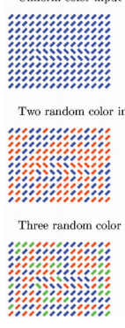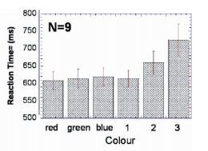

a.

b.

c.

d.

Figure 16 Stimuli used by Zhaoping and Snowden (2006) are shown in (a), (b), and (c), of single colour, two colour, and three colour conditions, respectively. Reaction times in ms are presented in (d) – the averages of the single colour conditions (red, green, and blue) are given as colour ‘1’ in the graph.

Further studies carried out by Zhaoping & May (2007) expanded on the number and type of psychophysical tasks that were explored, which included looking at differences in interference type (colour interference on an orientation salient task, or orientation interference on a colour salient task), the effect of conjunctions (target salient for two unique features), and looking at both visual segmentation and visual search tasks. They demonstrated a larger effect of colour interference on performance in an orientation salient task, than orientation interference on a colour salient task. This was explained in the context of V1 differences in processing colour and orientation; in V1, cells tuned to colour were described as having larger receptive fields (Livingstone & Hubel, 1984), and are stated as being present in the cytochrome oxidase-stained blobs of V1 more commonly than cells tuned to orientation, these blobs are associated with both higher metabolic activity and neural activity (Deyoe, Trusk, & Wongriley, 1995; Zhaoping & May, 2007) – however, more recent research has suggested that even though these areas are less orientation selective, the difference was not as great as previously indicated (Economides, Sincich, Adams, & Horton, 2011).

The primary aims of the fMRI experiments presented in the upcoming chapters were to establish whether or not saliency is determined in the early stages of visual processing. This is done by looking at whether differences in V1 activity can be observed as a function of different levels of iso-feature suppression – if iso-feature suppression occurs in V1, fMRI BOLD signals should be lower in conditions with high suppression (e.g. when all elements share a common feature such as colour, and the target is salient for its orientation), and there should be higher fMRI BOLD signals in conditions with less iso-feature suppression (e.g. when there is colour interference in an orientation salient task).

By first establishing the mechanisms involved in saliency detection in trichromats, we can make predications about the activity anticipated in dichromatic observers to different stimulus conditions. These experiments will include probing the colour-opponent channels (luminance, red-green, yellow-blue), as well as exploring the orientation thresholds necessary for identification of a target – in the event that dichromatic individuals have a higher proportion of cells tuned to orientation.

### Neuronal tuning and population Receptive Fields (pRFs)

The selectivity of cells – neuronal tuning – in the visual cortex has been much debated, and the techniques used for determining how neurons are tuned have also developed over recent years. Early studies by Livingstone and Hubel (1984) used single cell recordings to measure the firing rate of cells to particular orientations of stimuli. This work identified a functionally organised representation of orientation sensitivity in the interblob areas of V1, and colour-selective cells in the cytochrome oxidase (CO) stained blob areas of V1 (see Figure 17). However, further research has determined that neurons are not singularly tuned to one feature, e.g. orientation, and in fact cells are tuned (in varying degrees) to a number of different features, e.g. colour, orientation, motion direction, etc. For instance, McDonald, Mannion, Goddard and Clifford (2010) used human participants in an fMRI experiment to determine whether orientation sensitive cells were also chromatically defined. They found evidence of cells that were sensitive to orientations defined specifically by the L-M (red-green) and S-cone isolating (blue-yellow) channels. Similarly, and prior to McDonald et al, Johnson, Hawken and Shapley (2008) found that extracellular recordings of cells in the V1 of macaques showed variable sensitivity to combinations of colour, luminance contrast, and orientation, dependent on whether the cells were single- or double-opponent cells.

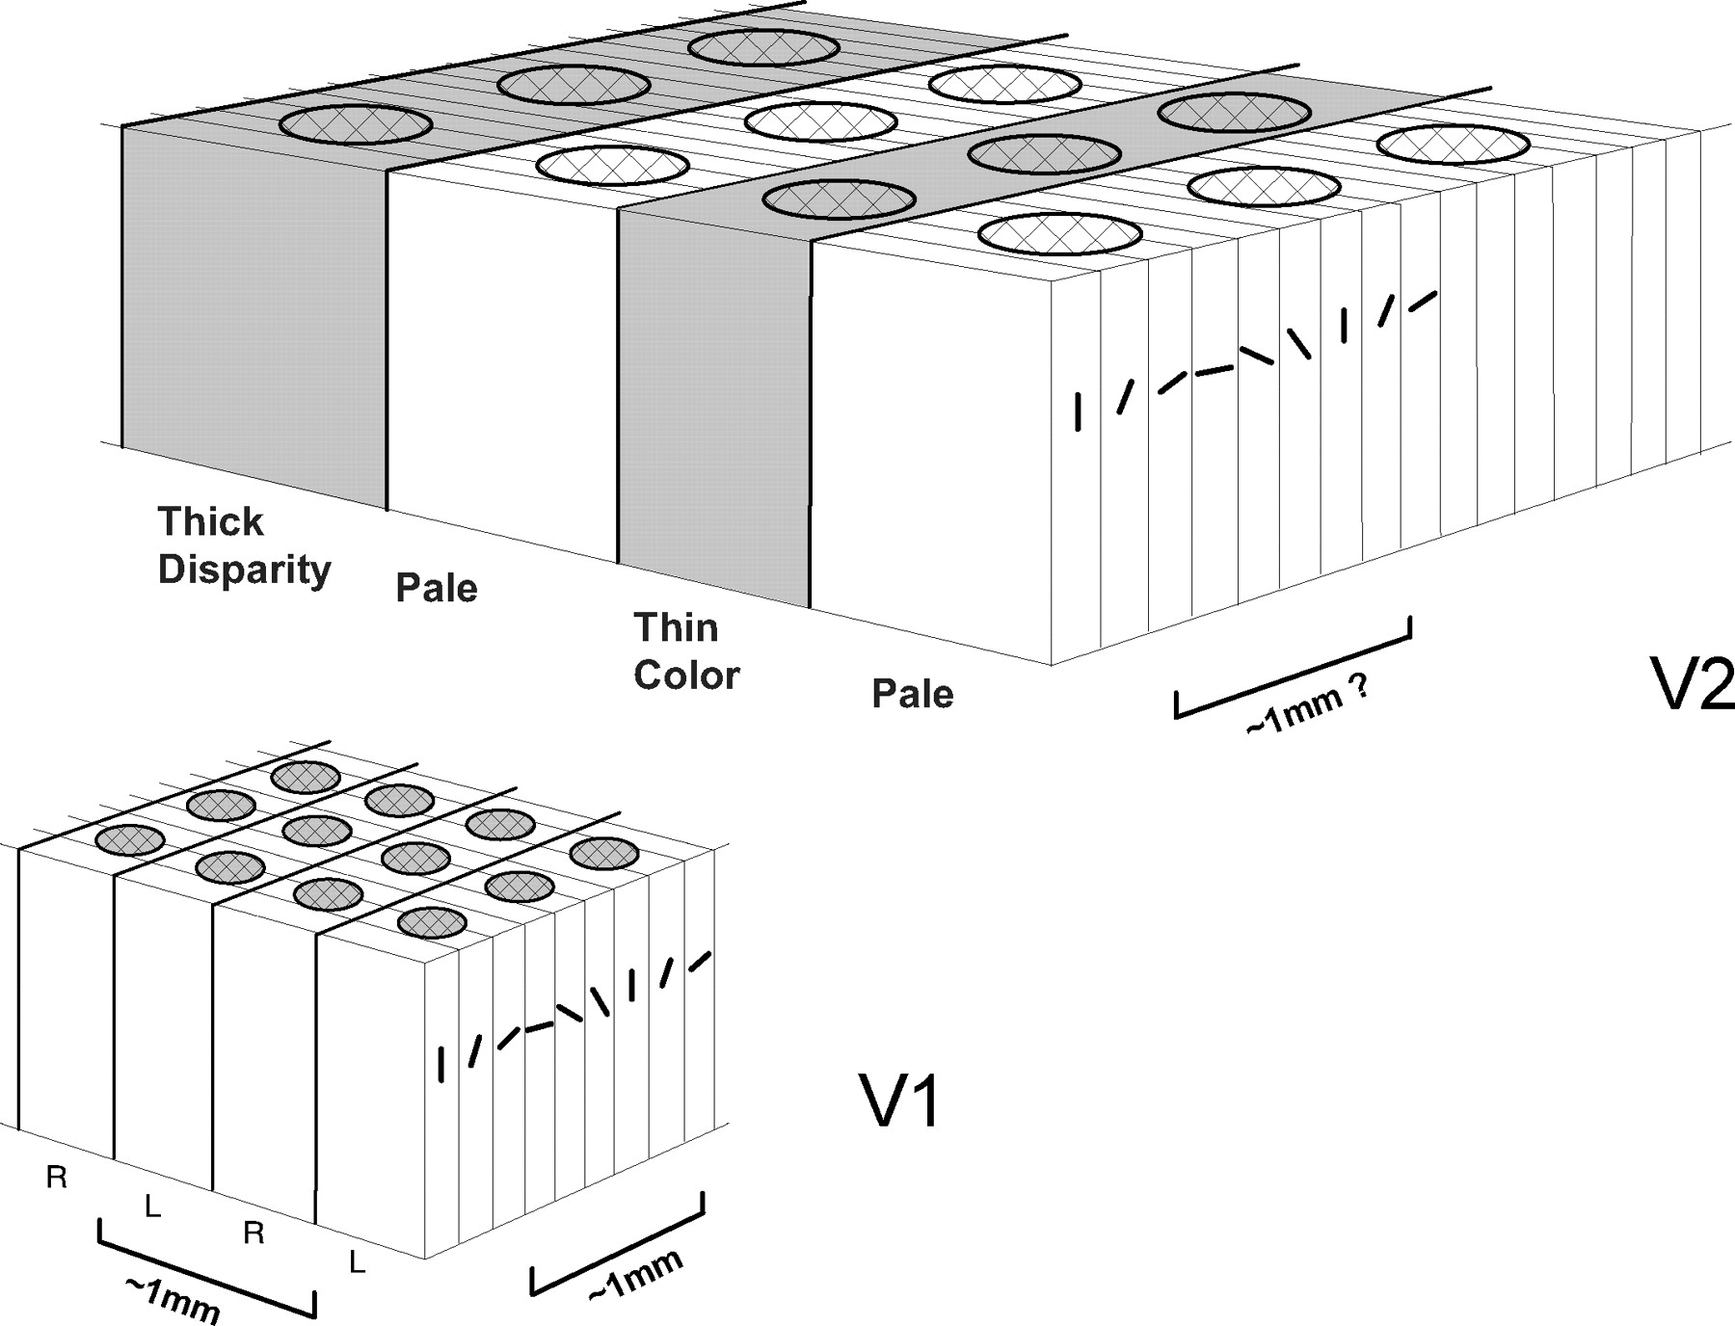

Figure 17 Hubel and Wiesel's 'ice cube' model of primate V1, showing the CO blobs (circular patches) in the centre of the ocular dominance columns and the orientation selectivity of the hypercolumns in the interblob areas (taken from Ts’o, Zarella, & Burkitt, 2009)

Visual field mapping of the visual cortex by fMRI, known as retinotopic mapping, is typically carried out using expanding ring and rotating wedge checkerboard stimuli (DeYoe et al., 1996; Engel, 1997), and results in a representation of visual space (eccentricity and angular polarity) in the different functional areas of the visual cortex (this process is demonstrated in Figure 18).

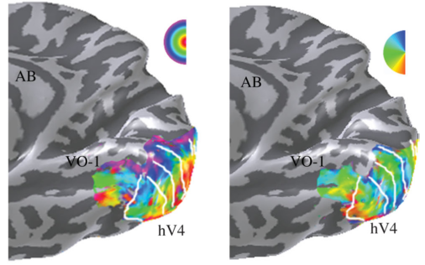

a.

b.

Figure 18 **Phase-encoded patterns of activity produced from (a) expanding ring and (b) rotating wedge stimuli. White lines show the boundaries between visual field maps such as ventral V1, V2 and V3. Taken from Wandell, Brewer and Dougherty (2005)**

However, a new technique was introduced by Dumoulin and Wandell (2008) to compute a model of the likely population receptive fields (pRF) of neurons based on the responses to a number of stimuli, which included those commonly used in visual field mapping techniques (e.g. “phase-encoded” expanding ring and rotating wedge checkerboard stimuli) as well as drifting checkerboard bars presented in a number of orientations and directions (see Figure 19). This technique can inform about the size and location of the population receptive fields in the visual cortex, but could also be utilised to help decipher chromatic neuronal tuning differences in dichromatic and trichromatic individuals. To date this technique has not been used for this purpose, however it is anticipated that by presenting different chromatic versions of the stimuli to participants it will be possible to encode information about the tuning of cells within the population receptive fields.



a.

b.

c.

Figure 19 Example of stimuli used by Dumoulin and Wandell (2008). a) rotating wedge, b) expanding ring, c) drifting bar.

Therefore, in order to evaluate how neuronal tuning differs in dichromatic individuals, pRF techniques with stimuli composed separately of L-M (red-green), S-cone isolating (blue-yellow), and luminance contrast, will be utilised to assess the ratio of response to each stimulus type in the areas identified by the visual field mapping. It is expected that this will enable an estimate of the proportion of cells tuned to each stimulus type, as well as being able to assess the overall size of population receptive fields. There are several possibilities in how dichromats and trichromats may differ based on the responses obtained from the different stimuli (the following is a not an exhaustive selection of the possibilities): 1) dichromats may have some comparatively smaller areas in the visual cortex in response to there being fewer cells tuned to L-M opponent channels, 2) dichromats may have a higher proportion of cells tuned to luminance contrast or S-cone isolating stimuli, 3) trichromats may be expected to have lower fMRI signal responses to S-cone isolating (blue-yellow) and/or luminance contrast stimuli compared to the responses of dichromats, 4) there may be no difference in size of population receptive fields, proportion of luminance to S-cone tuned cells, or the relative signal responses between dichromats and trichromats.

## Tetrachromacy

In a mid-20th century paper, de Vries (1948) described the fundamental response curves of red and green receptors in two women who were the daughters of a deuteranomalous man, and showed evidence that they possessed the same anomalous ‘green’ cones (in line with heredity predictions) as their father, as well as normal ‘red’, ‘green’ and ‘blue’ cones. It was therefore noted by de Vries, “…these daughters must be tetrachromatic…” (p380, 1948) – this was the first report of tetrachromacy as a result of being a genetic carrier for anomalous trichromacy. In the years following this study evidence of weak tetrachromacy has emerged, however the only case of strong tetrachromacy was reported by Jordan, Deeb, Bosten and Mollon (2010), where a single carrier of deuteranomaly (cDa29) performed as would be expected by a tetrachromat. Conversely, it was also found that a number of genetic carriers for anomalous trichromacy showed no evidence of performing any differently to a trichromat.

This component of the thesis is concerned with investigating the differences between heterozygous carriers of anomalous trichromacy that do and do not express evidence of functional tetrachromacy. The aim is to establish at which point in visual processing the signals from the additional cone type cease, ultimately preventing tetrachromatic colour vision. The following sections will describe genetic and physiological aspects of tetrachromacy, before describing the methods used by Jordan, Deeb, Bosten and Mollon (2010) to identify subject cDa29 as a functional tetrachromat. Finally, the methods that will be used to create a tetrachromatic stimulus in this thesis will be briefly outlined.

### Genetic and physiological aspects of tetrachromacy

A notable feature of tetrachromacy is that it is only possible for this type of colour vision to occur in females – this is due to the X chromosome location (Xq28) of the genes coding for the L and M cone photopigments (and therefore also any anomalous versions of the L and M cones) (Neitz & Neitz, 2011). These X-linked genes are highly similar in their nucleotide sequence, with a mutual identity of 98% between the genes for L and M cones (Nathans, Thomas, & Hogness, 1986). Furthermore, Asenjo, Rim and Oprian (1994) demonstrated that the large spectral difference between these two photopigments (of ~31nm) was determined by differences in only 7 amino acid residues.

In anomalous trichromacy, the primary cause of the anomalous pigment is unequal homologous recombination between the L and M opsin genes (Nathans, Piantanida, Eddy, Shows, & Hogness, 1986; Neitz & Neitz, 2011), which affects the precise structure of amino acids necessary for normal L and M cones. Males are most likely to express this type of colour blindness as they only have one X chromosome, which they receive from their mother – if the X chromosome contains anomalous L or M photopigment genes, that male will have anomalous trichromacy. Conversely, for a female to be a homozygous anomalous trichromat, they must receive the same anomalous gene from both their mother and father – this process of inheritance ultimately leads to a far higher proportion of females that are heterozygous (rather than homozygous) carriers of anomalous trichromacy (Gegenfurtner & Sharpe, 2001; Jordan et al., 2010). These heterozygous women are therefore carrying the genes for both normal L and M cones as well as an anomalous L or M cone.

A process known as random X chromosome inactivation determines which of the female’s X chromosomes will be expressed for any given photoreceptor cell, i.e. paternal or maternal genes for L and M cones. However, despite the name, it has been suggested that the process is not truly random, as there is a tendency for local clumping of the same cone types in the retina (Hofer et al., 2005). In fact, there is a debate regarding the arrangement of cones in the retina – with some data supporting the idea of clusters, such that in anomalous trichromats there may be clusters of normal and colour-deficient cones (Born, Grutzner, & Hemminger, 1976), and some finding that the arrangement is random (Roorda, Metha, Lennie, & Williams, 2001). Nevertheless, the ratio of maternal and paternal photoreceptors has been found to vary, with approximately 5% of females showing a ratio as high as 15:85 (Amos-Landgraf et al., 2006).

X chromosome inactivation is the first of two processes that determine the type of cone that is expressed. The second determinant is the binding process between the locus control region (LCR) and the opsin genes for L and M cones (or L’/M’) (see Figure 20**Error! Reference source not found.**). The L cone genes are located upstream of the M cone genes, and therefore have a higher probability (p = 0.66) of binding with the LCR, which is upstream of the L cone genes. Despite this probability, there are vast individual differences in whether the LCR binds with the first or second opsin gene, as demonstrated in the literature previously discussed regarding variation in L:M cone ratios (Carroll et al., 2002). These cone-determining processes ultimately result in a potentially vast range of cone ratio possibilities between carriers of anomalous trichromacy – some may have relatively equal numbers of each cone type, while others have much closer ratios to an anomalous trichromat, or to a trichromat. Therefore this may be a key factor affecting whether these women are functional or just structural tetrachromats. For instance, it may be expected that if the additional cone type only made up a very small percentage of the total cones, signals produced by those cones may not be enough to affect the perception of colour.   
1.4.2: Testing tetrachromats: Methods and Stimuli  
A number of tasks were utilised by Jordan et al (2010) to probe the abilities of the carriers of anomalous trichromacy. The first task was a Rayleigh Match procedure performed on an Oculus Anomaloscope, where the subject was required to match the brightness of the red/green mixture with the monochromatic field at given ratios of Red/Green set by the experimenter. In addition, the subject provided a rating on the quality of the match (where 5 indicated a perfect match) – only the Red:Green ratios scoring 5 were used to calculate that subject’s matching range. There were no significant correlations for the match mid-points or ranges between carriers and their sons, however the notable finding was that subject cDa29 did not accept any match for any of the Red/Green ratios presented. To further investigate this, a temporal 3-alternative forced-choice (3AFC) task was utilised to determine whether the potential tetrachromat could successfully discriminate between stimuli in a performance version of the Rayleigh Match. Three stimuli were presented in rapid succession, one of which was composed of a mixture of Red and Green light, and the other 2 were monochromatic orange lights (see Figure 21a) – the subject’s task is to indicate which of the 3 stimuli is the ‘odd one out’, i.e. the red and green mixture. Multiple trials were completed for a range of combinations of red/green ratios for the mixture stimulus and luminance for the monochromatic field. The lower graph in Figure 21b shows that cDa29 (open circles) makes no errors in identifying the red/green mixture across all red/green ratios – consistent with her performance on the Rayleigh Match task where she was unable to accept any matches – in contrast to the other carriers (‘cDa’ and ‘cPa’) and controls (‘mCo’ and ‘fCo’), who made the most errors in the 3AFC task for the red/green ratios that had they previously accepted as a match to the monochromatic orange field, i.e. they were unable to differentiate the mixture from the monochromatic fields, as expected.

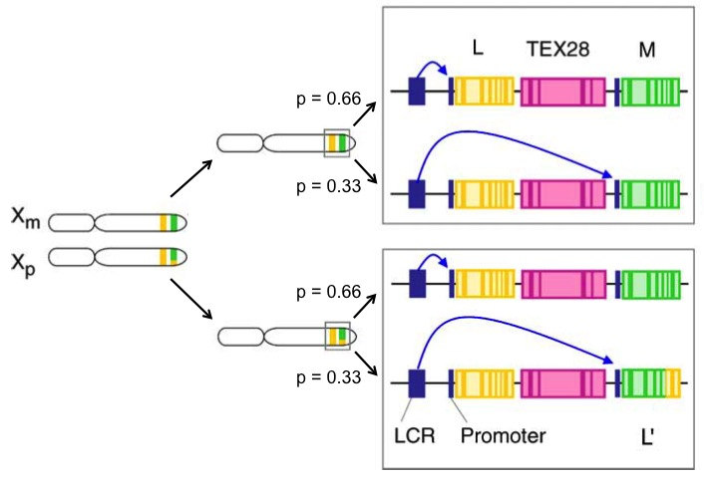

L cone gene

M cone gene

L’ hybrid cone gene

Figure 20 Example of the cone-type determinants (adapted from Jordan et al., 2010). Random X chromosome inactivation first determines whether the maternal (Xm) or paternal (Xp) X chromosome is activated. The cone type from that chromosome is then determined by whether the locus control region (LCR) binds with the promoter region of the first or second opsin gene (TEX28 is a non-opsin gene), approximate probabilities for each of these binding possibilities are shown.

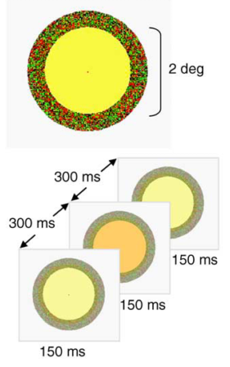

Figure 21 (a) Example stimuli and presentation of stimuli in the temporal 3AFC task. Each stimulus is surrounded by an annulus of colour noise. (b) response times (upper graph) and mean errors (lower graph) at each red/green ratio (R/(R+G))

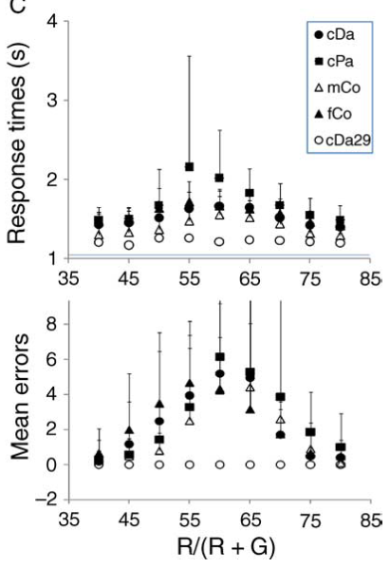

a.

b.

In addition to these tasks, further experiments using pigment mixtures were carried out to produce stimuli that were only distinguishable to the tetrachromatic observers, and indistinguishable to others.

Jordan et al (2010) ran genetic sequencing of all the carriers and their sons, to establish with certainty the genes that were carried, and the spectral peak of each of the photopigment genes they carried. Interestingly, individuals with similar spectral spacing of the L, L’ and M cones, did not perform equally to subject cDa29, suggesting that spectral spacing of the additional pigment may not be enough (though is likely important) in demonstrating functional tetrachromacy.

This thesis will describe a new multichannel LED system that has been created to further test tetrachromatic individuals, by using a cone isolation method. The cone isolation method involves optimally stimulating specific cones in order to measure the activity of the remaining ‘isolated’ cone – in this instance we will be creating a flickering cone isolating stimulus, that will only be visible to an individual with that particular cone. Tetrachromatic subjects should be able to perform at threshold on a 2 interval forced choice task (‘which stimulus was flickering?’) when each cone type is isolated (L, L’, M and S), whereas trichromats should perform at chance level for the L’ isolation and at threshold for the remaining cone types. As proof of principle that the stimulus is able to identify the presence (or absence) of particular cone types, the tasks will also be run on dichromatic and anomalous trichromatic individuals, with the expectation that the subjects will only perform at threshold for the cones that they possess, and at chance for the remaining cone(s). The aims are to produce a stimulus that is both effective in identifying functional tetrachromats as well as compatible for use in an MRI scanner. This latter aim is crucial for investigating visual processing of tetrachromatic stimuli in functional and structural tetrachromats.

# Unique hues – a longitudinal experiment

## Overview

Neurophysiological explanations for the unique hues have been persistently inconclusive, for instance, multiple factors have been shown to correlate with the large individual variation in unique green settings (REFS from CHPT 1), yet it remains a largely unexplained percept. However, explanations for unique yellow settings have, in recent years, garnered support from studies measuring the effects of adaptation (to artificially altered chromatic environments) on unique yellow settings. Chapter 2 will outline this research and describe a longitudinal experiment that was conducted to measure the sensitivity of the proposed mechanism by observing unique yellow settings following adaptation to natural, environmental changes that occur between winter and summer (in York, UK).

## Unique hues and adaptation

From paper drafts - In 1878 Hering noted that four colours are perceptually ‘pure’ – comprising a single hue rather than a mixture. However, a neurophysiological explanation for these ‘unique hues’ has evaded colour vision scientists for nearly 150 years. One of these unique hues, ‘yellow’, is particularly interesting because it is stable across large populations. Subjects reliably set a monochromatic light to a stereotypical ‘yellow’ wavelength despite the fact that different people’s long (L) to medium (M) wavelength sensitive cone ratios can vary by a factor of 30.

One explanation for this stability might be that unique yellow is set by the environment rather than retinal physiology. Some support for this idea has come from a study showing that long-term, artificial manipulation of environmental light conditions can alter subjects’ unique yellow settings, but evidence for this mechanism in natural settings has been absent until now.

There is large individual variability in the ratio of L- and M- cones in the human retina [9–11], and it has previously been suggested that this ratio could account for some of the variance in unique hues [12]. Whilst there is some recent evidence that these ratios may have an impact on unique *green* settings [13], Brainard *et al* [14] demonstrated that small differences in unique yellow wavelength settings – between individuals with diverse L:M cone ratios – could not be explained by a model that predicts a large impact of L:M cone ratios on this percept.

An alternative hypothesis is that unique yellow wavelengths are set by normalisation to the average chromatic environment. Previous studies have shown that adaptation to extreme, artificially induced, chromatic changes in the environment, can affect measurements of unique yellow [8], but until now it has been unclear whether changes in the natural environment also generate this effect.

Make sure to cover factors affecting UY and UG – discuss neitz, and the belmore papers, and the MPOD paper for UG.

## Aims & hypotheses

From the paper draft - In this study we explored whether unique yellow settings are affected by adaptation to fluctuating seasonal environments that occur in York, in the north of England. We also made measurements of two other chromatic percepts, unique green and Rayleigh matches, that would not be expected to change significantly after a reweighting of L:M cone inputs. The same set of subjects was tested twice, following adaptation to each of the seasons, and two sets of photospectrometer measurements of fixed locations were also taken to permit a spectral analysis of the changing seasonal environment.

The mean spectra of natural scenes change with the seasons [19]. These changes originate largely from systematic variations in surface reflectance spectra, rather than the illuminant. The dominant change for many environments is a shift to greener colours due to an increase in foliage in spring and summer. We hypothesised that if UY wavelengths are normalised by the environment, they would track these naturally occurring changes.

## Methods

### Subjects

We tested 72 participants in winter (January-February) and summer (June-July). Participants were only eligible for the study if, prior to each testing session, they had not been out of the UK for more than one week in the previous 3 months, and they must also have been in the UK continuously for a full month prior to the date of testing. These criteria ensured a minimum period of one month for environmental adaptation prior to each testing session.

The winter and summer testing sessions were separated by at least four months; the average number of days between testing sessions was 133 (± 11 days). Green foliage from deciduous trees had been absent for ~3 months prior to the winter session, and the regrowth of this foliage had been stable for ~2 months prior to the summer session.

Five participants were excluded from the data analysis; four (3 male, 1 female) made Rayleigh matches that indicated inherited colour vision deficiencies, whilst one female was excluded due to extremely poor repeat reliability of matches, indicating that this subject was a poor psychophysical observer. Therefore, 67 subjects (22 males, 45 females), with a mean age of 21.7 years (± 2.7), were included in the data analysis. All other participants were confirmed as colour-normal observers using Rayleigh matches.

The departmental Ethics Committee at The University of York granted approval for this study.

### Equipment

the equipment details. Troxler fading etc

spectral measurements with Jaz

temperature

A three channel colorimeter [22, 23], originally built at Imperial College London in the 1930’s, was used for making Rayleigh matches as well as on- and off-axis settings of unique green and unique yellow.

Measurements from the colorimeter were taken monocularly and stimuli were viewed through an eyepiece fitted with a doublet to counteract chromatic aberration. Depending on the measurement being taken, the participant either viewed a square, bipartite field (1.33° × 1.33°), or a single rectangular field (the bottom half of the bipartite field, resulting in a 0.67° × 1.33° viewing angle). The top half of the field contained a ‘‘mixing light,’’ which could contain a selection of primaries (blue, green, and red set at 460nm, 530nm, and 650nm, respectively). The observer could then adjust the intensity of each of these primaries independently. The bottom half of the field contained a monochromatic light, which could be set to a specific value for use as a “reference light”, to be matched by the mixture in the top half of the field. Alternatively, this half of the field could be used as a “test light”, and be manipulated in isolation until a particular wavelength value was obtained (e.g., perception of unique yellow).

The colorimeter was calibrated for each season of testing with a fibre-optic photospectrometer (‘‘Jaz,’’ Ocean Optics, FL) operating at 2 nm resolution. This device was, itself, calibrated against a National Institute of Standards Technology-traceable standard light source. Calibration allowed us to fit and correct slight nonlinearities in the colorimeter scale which were modelled with a second order polynomial. The same photospectrometer was also used to obtain measurements of the spectral environment at three fixed outdoor scenes, using a 30° spatial integrating lens.

Optical devices, such as colorimeters, may be sensitive to seasonal temperature changes [24]. To account for this, the temperature of the lab was monitored throughout each season of testing using a digital thermometer, accurate to +/- 1°C (1.8°F). The temperature was comparable between seasons (winter: M=24.08 (°C), SD=1.70; summer: M=24.07, SD=1.63), and no correlation was found between any of our measures and the temperature at the time of testing.

### Design

what was tested – Rayleigh matches, on- and off-axis ug and uy

temperature

### Procedure

order of experiment, dark adaptation etc.

calibration – use of equation for converting values from colorimeter. Look up the red and green values used for the Rayleigh matches – check with Tony!

Describe spectral measurements taken (stress that they are a sample).

Exclusion of 1st measurement from 6.

**Colour matching and unique hues:**

For the Rayleigh matches subjects viewed the bipartite field through the eyepiece of the colorimeter while resting on a chin support. The bottom half of the field was set to a reference wavelength of 585nm, and the top half of the field was composed of red and green primaries (set at 650nm and 530nm, respectively). The subject was instructed to adjust the amount of each primary in the top half of the field, making as many adjustments as necessary, until it appeared to perfectly match the bottom half of the field in both colour and brightness. Following this initial match, a further six matches were made, giving a total of seven Rayleigh matches made by each subject; three matches were made by adjusting the green primary while the red primary remained at the value of the initial match, and the final three were made by adjusting the red primary, while the green primary was set to its average value (obtained from the previous matches). Between each match, the primary due to be adjusted was reset to a randomised starting value. Rayleigh matches were converted to log(R/G) prior to analysis, where R and G are the relative radiance of the red and green primaries, respectively. The means and variances of the matches were used to identify whether any subjects showed evidence of inherited colour-vision deficiencies. As stated previously, this resulted in the exclusion of five participants.

For the unique hue settings, the top half of the bipartite field was occluded, and subjects were required to adjust the wavelength of the bottom half of the field until they perceived it to be the specified unique hue. Unique green was described as the point at which the stimulus appears neither yellowish nor bluish, and unique yellow was described as the point at which the stimulus appears neither reddish nor greenish. Prior to making the adjustments for each unique hue, the subjects were instructed to spend time exploring the range of colour either side of the specified unique hue (i.e. from yellow to green and then blue, for unique green, and from red to yellow and then green, for unique yellow). Subjects were also advised to make very small adjustments of the dial in order to best achieve the required unique hue. Both on- and off-axis measurements of the unique hues were obtained; the off-axis measurements (at 6.5° eccentricity) were taken outside the fovea to remove any effect of macular pigment on the measurements.

Beginning with on-axis unique green, the subject fixated on the stimulus and carried out six repeats of the adjustment, with the experimenter randomising the starting value between each adjustment. Off-axis unique green measurements were then obtained by placing a small, dim fixation LED at 6.5° to the right of the stimulus location (measured from the centre of the stimulus). This placed the stimulus in the left visual field. In addition, a 4Hz square wave flicker was applied to the stimulus to reduce Troxler fading [25]; this was achieved by spinning a metal disc that alternated between 90° filled sectors and 90° gaps. Subjects were instructed to maintain fixation on the LED at all times. Each subject also carried out six repeats of the off-axis unique green adjustments. The process of obtaining on- and off-axis measurements was then repeated for unique yellow.

A final concern was that despite a five minute period of dark adaptation at the beginning of the session, observers might maintain weak photoreceptor-level adaptation to either the previous experimental stimuli or the recent outside environment [29]. To test for stimulus ‘history’, we analysed our data to identify an effect of trial order. We found that the first trial of each set of six differed significantly from the remaining five, but that subsequent trials were statistically stable and showed no correlation with trial order (see Table S1 in supplemental material). Therefore the first trial was excluded prior to averaging. It has previously been shown that short-term chromatic adaptation may alter the saliency of chromatic targets [30], but it does not reduce or disguise any very-long-term adaptation effects that are present in UY measurements [11, 31]. Others [32] have shown that short term chromatic adaptation effects have a half life of around 20 seconds. Therefore, we do not expect that cone-level adaptation caused by short-term environmental adaptation immediately before the experiment would impinge on very-long-term adaptation effects caused by seasonal environment.

**Spectral measurements:**

Three “ground” locations were selected from outside scenes around the Department of Psychology at the University of York. The positions at which these measurements were taken were marked to ensure the repeat measurements taken within and between seasons were always at the same precise position and angle. The locations were examples of the environment regularly experienced by our subjects (students at the University of York), and contained a combination of man-made objects (cars, buildings, pavements, etc.) and natural surfaces (trees, grass, shrubbery, etc.). Measurements were all taken at approximately 2pm using three different integration times (25ms, 35ms and 50ms), to account for day-by-day differences in light levels and to avoid sensor saturation. The intensity measurements were recorded as photon counts over the range of 339.6 to 1029.8nm in steps of approximately 0.3nm; these were reduced and resampled to match a scale of 400-700nm (in steps of 1nm) prior to analysis, to represent the visible spectrum better. Finally, measurements were adjusted to absolute intensities by dividing all values by the integration time for that measurement.

## Results

### Unique hues

To avoid performing multiple comparisons of our repeated measurements of UY and UG, which were carried out in two seasons for both on- and off-axis eccentricities, we first ran a univariate repeated measures ANOVA with the dependent variable of wavelength and factors of season, eccentricity and unique hue type. We found no significant main effects of either season (*F*(1,66)=1.277, *p*=.263) or eccentricity (*F*(1,66)=2.901, *p*=.093), however we did find a significant interaction for unique hue type with both season (*F*(1,66)=5.202, *p*=.026) and eccentricity (*F*(1,66)=22.975, *p*=.00001). To investigate these interactions, we repeated the ANOVA for UY and UG separately to identify any overall effect of these factors.

We found a significant main effect of season on UY wavelength settings (*F*(1,66)=19.278, *p*=.00004), but not on UG wavelength settings (*F*(1,66)=.360, *p*=.551). We also found a significant main effect of eccentricity on unique hue settings, which was present for both UY (*F*(1,66)=9.493, *p*=.003) and UG (*F*(1,66)=11.641, *p*=.001). There was no significant interaction between season and eccentricity for either measure (UY: *F*(1,66)=.781, *p*=.380; UG: *F*(1,66)=.019, *p*=.891). It should be noted that we also found the same significant effect of season on UY (and no effect on UG) when we analysed the data with the unstable first trials included.

Post hoc paired *t*-tests with Bonferroni correction (see supplemental material) showed that the mean on-axis UY wavelength setting decreased between winter (571.81nm ± 4.81) and summer (570.26nm ± 4.99) (*t*(66)=3.072, *p*=.012), as did off-axis UY (winter: 570.76nm ± 3.94; summer: 568.75nm ± 4.95) (*t*(66)=4.374, *p*<.0004). Although a trend for longer wavelength settings in summer was observed for UG, this was not significant. Paired t-tests on the Rayleigh matches also showed no significant change between seasons.

The mean differences between seasons (calculated on a subject-by-subject basis prior to averaging) for both eccentricities of UY and UG, and for the Rayleigh matches, are plotted in Figure 2, with 95% CI error bars.

In short, we found that UY settings shifted to shorter wavelengths in summer compared to winter, but that UG and Rayleigh matches were unchanged.

### Rayleigh matches

report data from Rayleigh matches, and the exclusion criteria, show diff between seasons (i.e. no dif)

### Spectral measurements

plot average difference between seasons at each location. etc

also plot in LMS space

For each of the measured locations, we calculated the ratio of the mean seasonal spectral measurements. Figure 1a illustrates these data with an additional dashed reference line indicating a typical peak reflectance for green vegetation (as estimated in NASA Reference Publication 1139 [20]). The peak difference for all the measured locations occurs around the average peak reflectance of vegetation. For the locations we measured, the largest change between seasons was an increase of ‘green’ in the environment in summer compared to winter.

Spectral measurements were converted into MacLeod and Boynton [21] cone space in order to compute seasonal changes in cone absorption rates. LMS excitation values were computed using the 2° cone fundamentals [22] downloaded from the Colour and Vision Research Laboratory online database (www.cvrl.org). Figure 1b plots the means and standard deviations of these measurements in the S/(L+M) vs. L/(L+M) cone space for each location. Repeated measures ANOVAs showed a significant main effect of season on the L/(L+M) dimension (*F*(1,2)=20.641, *p*=.045), with no main effect of (or interaction with) location; higher L/(L+M) values in the winter are consistent with findings reported by Webster, Mizokami and Webster [19]. No significant main effect of season was found for the S/(L+M) dimension (*F*(1,2)=5.198, *p*=.150), despite a trend for higher values in winter.

Finally, we used a repeated measures ANOVA to compare the L:M absorption ratios for the spectral measurements taken in each season at each location. There was a significant main effect of season on the L:M ratios (*F*(1,2)=19.680, *p*=.047), and no main effect of (or interaction with) location. Average L:M ratios (grouped across locations) decreased between winter (1.1686 ± .0147 (mean ± SD)) and summer (1.1606 ± .0104). The scene containing the most summer foliage changed between 1.182 (± .018 SD) and 1.157 (± .007 SD) (*t*(7)=2.908, *p*=.023).

### Lab temperature between seasons

report change in temp between seasons, correlations with measurements for summer season

The lab temperature was comparable between seasons (winter: M=24.08 (°C), SD=1.70; summer: M=24.07, SD=1.63), and no correlation was found between any of our measures and the temperature at the time of testing.

## Discussion

### Controls and considerations

i.e. measurements of Rayleigh matches not expected to change. effect of temperature – Richter stuff.

short term cone adaptation – exclusion of the first trials.

### Unique yellow settings shift between seasons

summarise this observation and compare to shift observed by Neitz et al

#### Modelling

report modelling which is in line with prediction

### Unique green modelling

report unique green modelling and why we may not have seen shift (small shift predicted, but lots of noise in data)

### Modelled shift using spectral measurements

use the spectral measurements to indicate shift in.

Make clear the limitations here, i.e. it’s indicative but by no means a comprehensive account of environment change. suggest how could have been done better – i.e. recording full days of data from several individuals.

### Implications for thesis

what does this mean for ‘colour perception’ – dynamic long-term adaptation to natural changes in average ‘colour’ of environment

## Conclusion

summarise all. link back to main thesis and what this longitudinal experiment told us

# Saliency – a preliminary investigation

## Overview

relating to colour blindness

## Experiment 1: saliency and camouflage

### Introduction

background and hyps. Zhaoping and the Mollon work.

### Methods

#### Subjects

#### Equipment

#### Design

#### Procedure

### Results

#### Colour vision testing

allocation to groups – anoms vs trichromats vs dichromats

#### Reaction time data

#### Accuracy data

### Discussion of Experiment 1

#### No difference between groups

#### Limitations of the stimulus

## Experiment 2 – fMRI and saliency

### Introduction

background and hyps. V1 saliency hyp etc

### Methods

#### Subjects

#### Equipment

#### fMRI protocols

#### Experiment Design

#### Procedure

### Results

#### Identifying ROIs

using the localiser for stim location

#### Activity differences between conditions

what info was extracted for each condition and plot results

### Discussion of Experiment 2

#### V1 saliency hypothesis

discuss how our data supports it.

#### Implications for the thesis

what does this tell us… why is it useful…..does this help us move onto focusing on contrast? maybe try link it to that investigation

## Summary of Results

summarise data from both experiments

## Discussion

## Conclusion

# Visual Processing in Dichromats

## Overview

new line of research for dichromats, following the saliency exp. Move to theory regarding reallocation of neurons to result in benefit to contrast detection at high level contrast pedestals.

Look into the studies on dim light conditions and how this affects dichromat performance… I think the literature is mixed – see what conditions were, maybe there were larger contrast differences in some scenes over others?

## Contrast Detection

go into the lit on this topic – primarily for trichromats and non-human primates for neural populations. look at the Janaky et al paper – though may be a good discussion point, came out after experiment was designed and therefore wasn’t found before running all subjects – note that it is for foveal stim, and ours was peripheral, so once scaled for cortical magnification our cpd freq was prob equivalent to theirs and therefore optimum for being able to observe any differences.

## Aims and Hypotheses

Split into Experiment 1 and 2??? i.e. experiment 1 would be the version that the 3rd years ran, and experiment 2 would be the optimised version – i.e. fewer levels and more trials to produce better psychometric function fits.

experiment one had, for each pedestal level, over 3 runs had 150 trials total, with 20 target levels. Experiment 2 had over 4 runs 200 trials total, with 10 target levels.

## Experiment 1

### Methods

#### Subjects

#### Equipment

#### Design

#### Procedure

### Results

#### Diagnosis of colour vision deficiency

#### Fitting psychometric functions

#### Bootstrapping the data

### Discussion of Experiment 1

## Experiment 2

### Methods

#### Subjects

#### Equipment

#### Design

#### Procedure

### Results

#### Diagnosis of colour vision deficiency

#### Fitting psychometric functions

#### Bootstrapping the data

### Discussion of Experiment 2

#### Analysing group differences

small numbers of dichromats limit the ability to use traditional t-test based analysis.

#### Implications of data

we only see difference at high contrast pedestal

Discuss the procedure used (randomised trials) and the effect this has on the ‘dipper function’ (though shouldn’t affect high contrast pedestal level).

Work out the resolution of the monitor (based on graphic card and monitor capabilities) – what’s the smallest contrast increment it can actually make? i.e. how accurate are the thresholds at low contrast.

#### Support of reallocation hypothesis

## Conclusion

based on both experiments. lead into pRF

# pRF mapping

## Overview

overview of what it is, what it could be utilised for in relation to dichromats.

## pRF mapping techniques

go through the technique – what it is, how the modelling works, etc

## Aims and hypothesis

## Experiment 1: pilot chromatic pRF mapping

### Introduction

using the 2.5deg bars

### Methods

#### Subjects

#### fMRI protocol

#### Experiment and stimulus design

#### Protocol

### Results

#### Retinotopic maps and ROIs

#### Size of visual areas

#### pRF size versus eccentricity

### Discussion of Experiment 1

#### Pink noise vs drifting checkerboards

our data versus the wandell dumoulin data

#### Consequence of bar width

combo with pink noise results in the pRF sizes at 0.5deg eccentricity being higher than that found by dumoulin and wandell

## Experiment 2: chromatic pRF mapping in trichromats

### Introduction

edited bars to 0.5degs

### Methods

#### Subjects

#### fMRI protocol

#### Experiment and stimulus design

#### Protocol

### Results

#### Retinotopic maps and ROIs

#### Size of visual areas

#### pRF size versus eccentricity

### Discussion of Experiment 2

#### Effect of narrower bars on pRF sizes

#### Differences between chromatic pRF data/why doesn’t it work

## Experiment 3: chromatic pRF mapping in a dichromat

### Introduction

same stim as in experiment 2

### Methods

#### Subjects

#### fMRI protocol

#### Experiment and stimulus design

#### Protocol

### Results

#### Retinotopic maps and ROIs

#### Size of visual areas

#### pRF size versus eccentricity

### Discussion of Experiment 3

#### Difference between achromatic and chromatic conditions

## Discussion of Results

## Conclusions

## Summary

# Development of cone isolating stimuli

this will be a breakdown of all the preliminary experiments leading up to chapter 5, which will be the final (hopefully working!) version of the stimuli used on actual carriers of anomalous trichromacy plus hopefully some fMRI

## Overview

stuff from intro here?

## Method used

Cone isolation / silent substitution.

principles of the code:

We use a transformation matrix to calculate the output of each LED necessary to excite particular cones. We do this by measuring the spectra of each LED with a fibre-optic photospectrometer – from the point at which the observer would view it, i.e. after the numerous LSDs and travelling down fibre optic cable. We then obtained the cone fundamentals (sensitivity curves) for the photoreceptors, using the 2degree cone fundamentals from Stockman & Sharpe.

To calculate the Cone2LED matrix, we first establish how the LEDs affect the cones, i.e. LED2Cone:

this is done by multiplying the LEDspectra by the cone spectra, this outputs a matrix of nLEDs x nCones which tells us how each LED excites each cone.

Plot the sinewaves of each LED as example for one condition (look at the code for creation of sinewave in Matlab/arduino and plot output amp of LED against time) – can also show what the baselevel is for each LED.

## Experiment 1: Developing the LED equipment

### Introduction

background and hypotheses

### Method

#### Subjects

#### Equipment

#### Design/fMRI

#### Procedure

describe setup of first prototype/model i.e. dac connecting between prizmatix and pc. DAC is identified through Matlab as the Measurement Computing Controller (MCC). Matlab can be used to control the output of each bulb (e.g. by adjusting the brightness and flicker rates). We used 4 of the 5 available LEDs to test whether or not we’d be able to produce cone isolating stimuli. we first looked to isolate channels rather than separate cones. this was done behaviourally and within fMRI. the fMRI data showed the expected pattern of excitation in response the different stimuli at different frequencies, i.e. lum respond best at slightly higher frequencies (worse at lower or very high freqs), whereas L-M and S-cone get highest responses at low frequencies.

**** first fMRI pilot with this stimulus was done with Sam Lawrence – we were able to get good neuronal responses to the 1degree stimulus – stim was presented at dif frequencies and we saw exactly the pattern of responses that we would expect, i.e. Lum responds optimally at about 16hz, whereas s-cone and l-m respond best at lower frequencies. used a different method of control (via the daq and Matlab rather than the arduino, for the daq we needed to do the PWM in the matlab code for the LED outputs, but this is now done on the arduino). LEDs are rapidly turned on and off to reach the desired brightness of each LED at any given time.

Describe the stimulus design in the scanner – randomised order of stim in block design

15m Fibre optic cable

Light Shaping Diffusers

Black surround with window to create a 1° visual angle

5-channel LED light source

### Results

#### Psychophysics?

#### fMRI data



Luminance

Red/Green

S cone

4Hz 16Hz 32Hz

4Hz 16Hz 32Hz

4Hz 16Hz 32Hz

### Conclusion

## Experiment 2: Modification of equipment

### Introduction

what this experiment was for, etc…

Pilot with 4LEDs (due to a temporary technical fault with one of the LEDs), testing L-M , LMS and S cone channels using trichromats, dichromats and anomalous trichromats.

We would expect the colourblind subjects (definitely the dichromats, and possibly the anomalous trichromats depending on the shift of their anomalous cone) to be able to get contrast thresholds for the LMS and S cone conditions, but not for the L-M.

### Method

#### Subjects

#### Equipment

#### Design

#### Procedure

Basic stimuli was used for this – the sine wave presentation of the stimulus was not randomly phase shifted for each trial.

Used an Arduino Mega and Matlab to control 4 LEDs – 410, 465, 535 and 630nm.

2 interval forced choice task was used, both had a baseline ‘white’ light but one interval contained the flickering ‘channel’ isolating stimulus on top of this, and the other did not. Numerous (4?) LSDs are used after light has travelled down a 15m fibre optic cable to further mix the light sources.

Stimulus was presented at 2Hz. Pulse width modulation was used to control the output of the LEDs using the arduino. The Prizmatix LED box was connected to the Arduino using DNC cables and a serial port, from which wires connected the serial port to the relevant PWM pins of the arduino (along with a ground).

### Results

#### Between groups (all at 2Hz)

#### One subject at different frequencies

### Conclusion

## Experiment 3: Accounting for a 4th cone

### Introduction

discuss the pilot to determine the optimum frequency to use for the Lprime so max contrast can be used.???

### Methods

#### Subjects

#### Equipment

#### Design

#### Procedure

All 5 LEDS working – first want to establish optimum frequency to use for cone isolation. so with our LMS stim (i.e. accounting only for three cones), we run L and M cone isolating stimulus tasks at various frequencies to identify optimum frequency for a 1second stimulus, i.e. which frequency achieved the lowest contrast thresholds in the 2IFC task. Two subjects used testing at frequencies 1, 2, 4, 8hz, with 3 repeats of each. Plot the contrast thresholds for each subject on same graph.

*** maybe this should just report results after the luminance noise is added in to each interval?

### Results

### Conclusion

# Tetrachromat testing

## Overview

## Experiment 4 – Psychophysics

### Introduction

### Methods

#### Subjects

#### Equipment

#### Design

#### Procedure

### Results

### Conclusion

## Experiment 5 - fMRI

### Introduction

### Methods

#### Subjects

#### Equipment

#### Design

#### fMRI Protocols

#### Procedure

### Results

### Conclusion